**PSY 653 Module 6: Time series and the analysis of longitudinal data**

**Gemma Wallace & Neil Yetz**

**Mar 4, 2020**

Use the following experimental design to complete the tasks below:

200 college students’ GPAs were assessed at 6 different timepoints (i.e., 1200 data points total) over the course of one semester. We are interested in investigating if and how GPA may have changed across the semester. In addition to GPA, the study also measured each student’s self-reported sex identity and their job status (i.e., working part-time or full-time jobs in addition to their academic responsibilities). The datafile for this activity is named “Longitudinal.csv”.

We will conduct two sets of models to (a) examine how GPA changes over the six timepoints and (b) examine how GPA changes over the six timepoints and across participant sex identity.

*The data contains the following variables:*

**student** = participant ID number (N = 200)

**occas** = A 6 level factor indicating the time point (0-5)

**gpa** = Grade Point Average (0-4)

**job** = participant job status (0 = part-time employment status and 1 = full-time employment status)

**sex =** self-reported sex identity (0 = male, 1 = female)

1. Create a new R notebook and load the following libraries: psych, tidyverse, lme4 and lmerTest (Note: you will likely need to install lme4 & lmerTest)

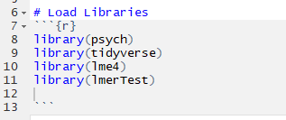

1. Read in the datafile “Longitudinal.csv” and get variable descriptives

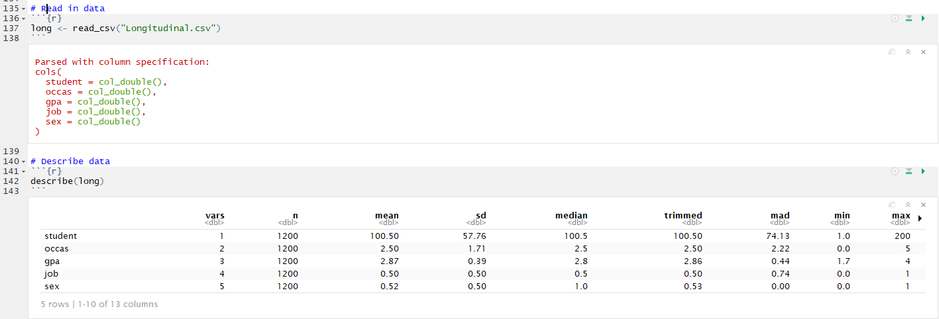

1. Use the aggregate() function to examine how the mean value of GPA may vary across the six timepoints

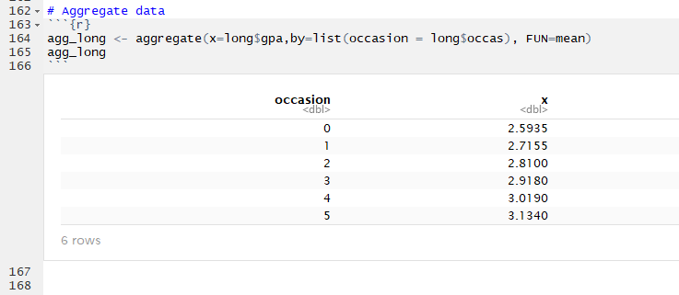

1. Use ggplot to visualize how GPA changes over time in the *full* sample

**METHOD 1: pulling from your aggregate object (agg_long)**

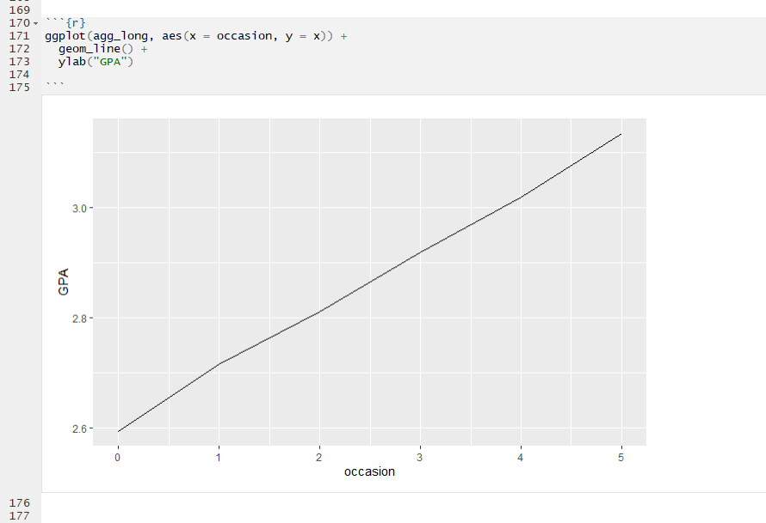

**METHOD 2: Utilizing the entire dataset object (long)**

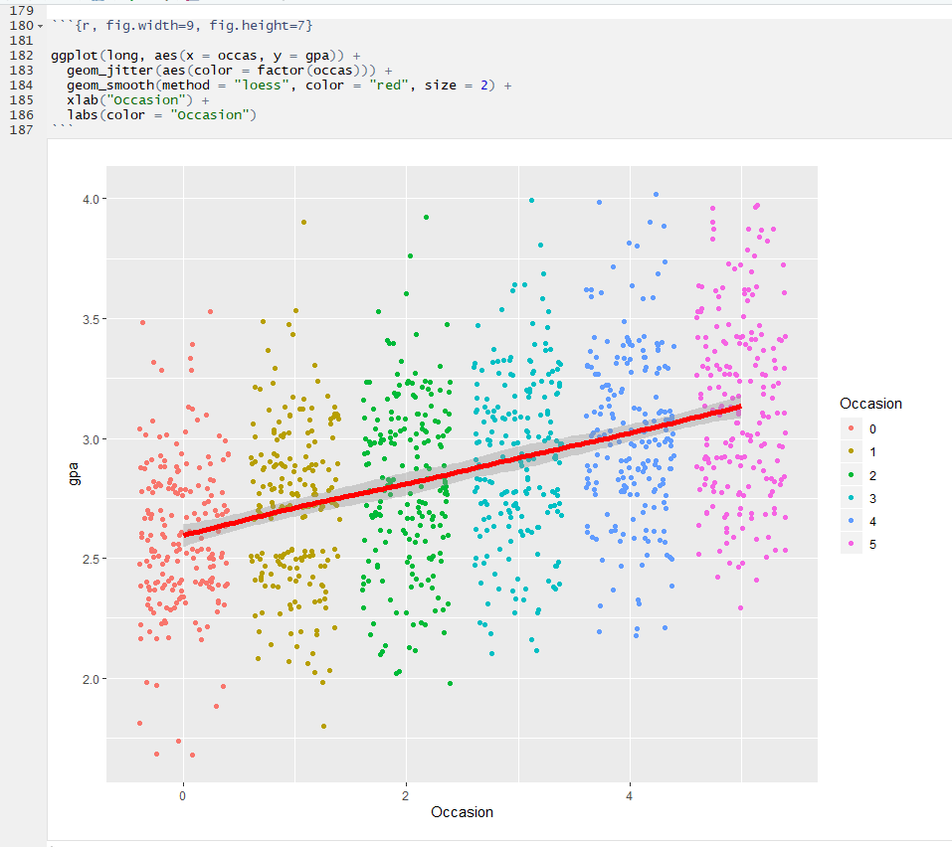

* 1. Briefly interpret the graph. Why is it important to visualize the data in this way?

**There appears to be a linear upward trend in GPA across occasion. It is important to visualize data in this way to see what the trend is showing. Viewing data this way can help to determine if the trend is linear, quadratic or has multiple bends in the data.**

1. Use ggplot to visualize how GPA changes over time for *each individual* participant

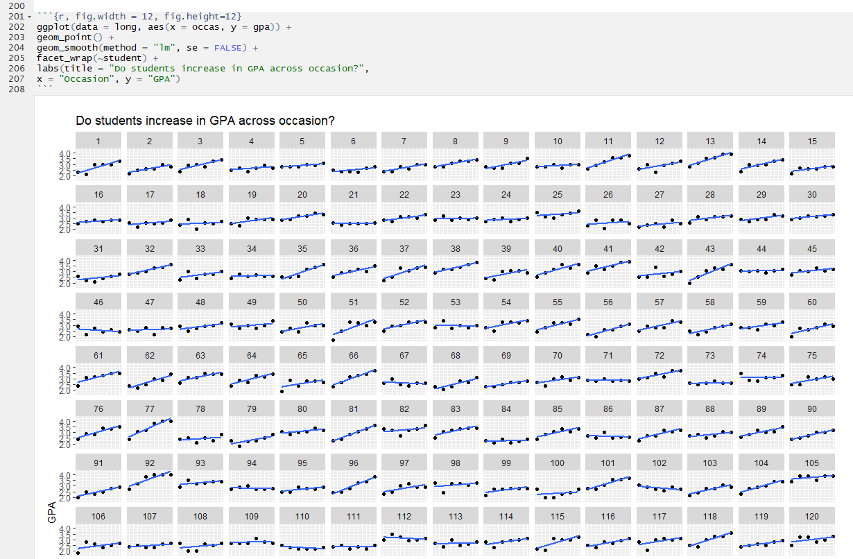

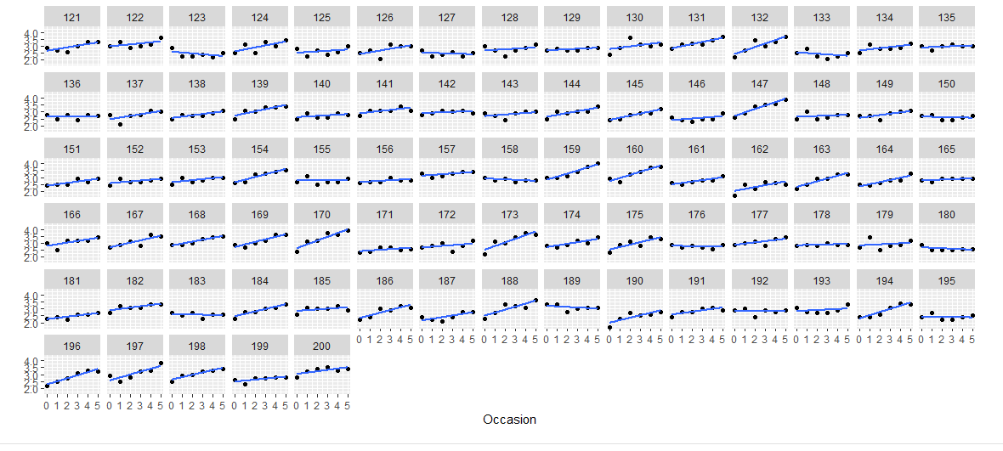

* 1. Briefly interpret the graph. Why is it important to visualize the data in this way?

**The graph shows that there is variation between each subject in how they progressed in GPA across occasion. Some participants’ GPA rose, others decreased, and some stayed the same. It is important to visualize data in this way because we need to see how much our subjects vary from one another.**

1. Use ggplot to visualize how GPA varies across both the six timepoints and by sex identity

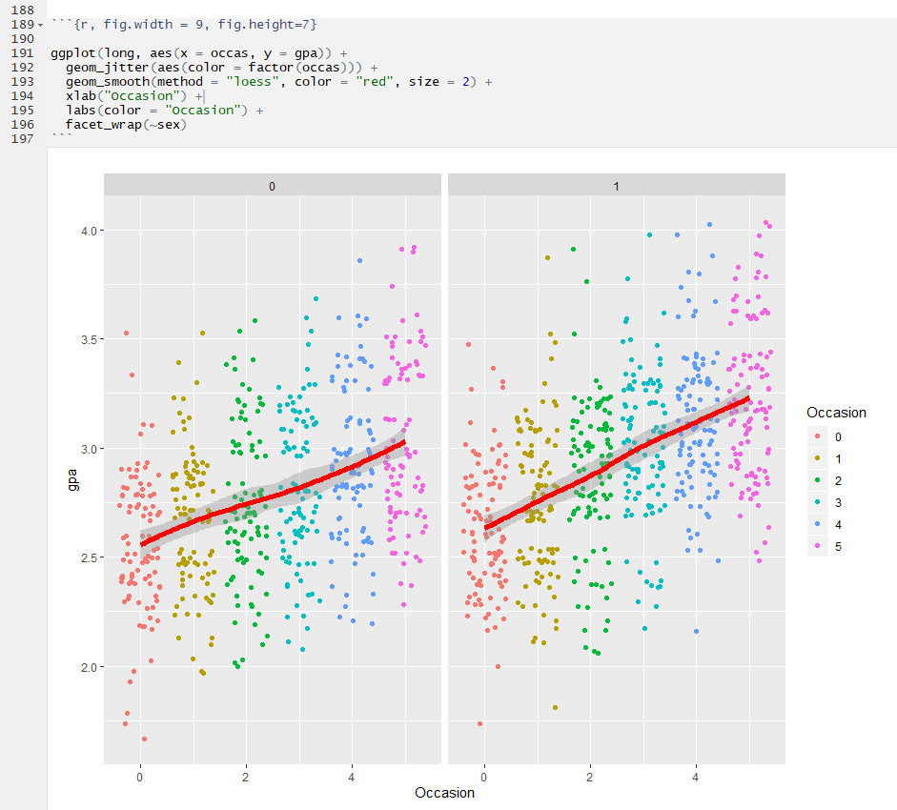

* 1. Briefly interpret the graph. Why is it important to visualize the data in this way?

**There appears to be a linear upward trend in GPA across occasion for both groups. It is important to visualize data in this way to see what the trend is showing. Viewing data this way can help to determine if the trend is linear, quadratic or has multiple bends in the data and to see if it is different between groups.**

* 1. Based on the three plots you just created, do you think you have justification to test for a linear effect of time on GPA? What about a quadratic effect?

**Yes, we have justification to test for a linear effect of time on GPA. No, we do not have justification to test for a quadratic effect because the trend appears linear.**

1. Test the intercept-only model (i.e., the baseline model) for GPA

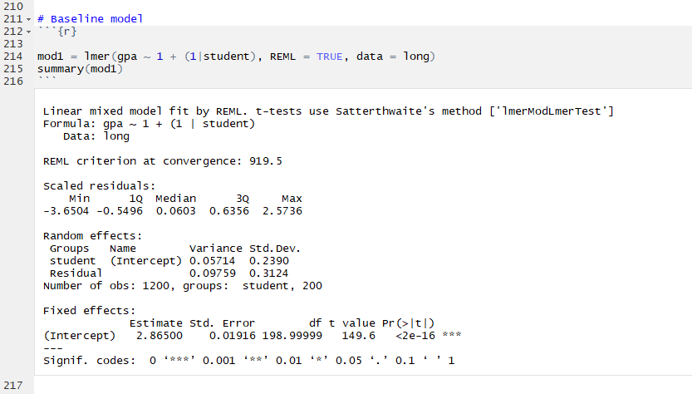

* 1. Interpret the model output

**Random Intercept: On Average, students mean GPA varied by 0.2390 Standard deviation across all timepoints.**

**Fixed Intercept: The average student GPA for all students across all timepoints was 2.865 (The mean of means)**

1. Test a linear growth model to determine how GPA changes across the six timepoints

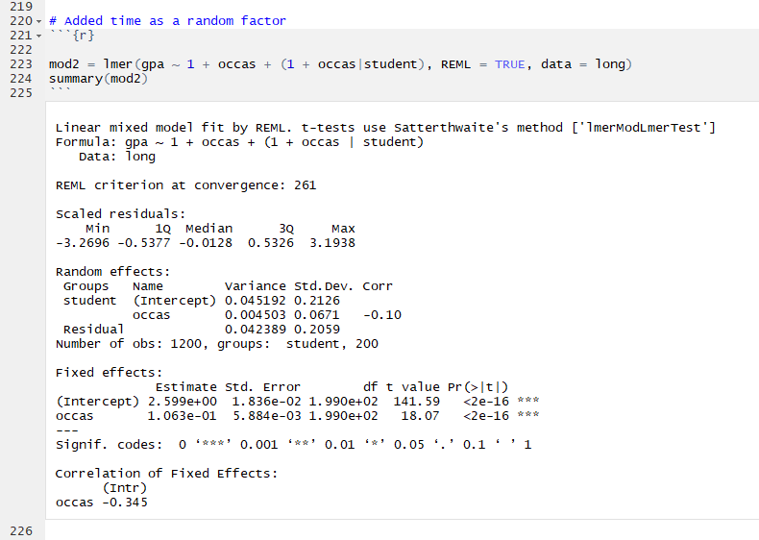

* 1. Interpret the model output. Do results indicate the presence of a linear effect?

**Random Intercept: Students starting GPA varied by an average of 0.2126 standard deviations during occasion 0.**

**Random Slope: Students change in GPA across occasion (The slope) varied by an average of 0.0671 standard deviations.**

**Fixed Intercept: On average, student starting (Occasion zero) GPA was 2.599**

**Fixed Slope: On average, Student GPA increased by 0.1063 units across occasion.**

**YES, these results indicate the presence of a linear effect (fixed slope p <.05).**

1. Now we will add a covariate to the model: sex identity. Test the baseline model for GPA that also includes sex as a covariate

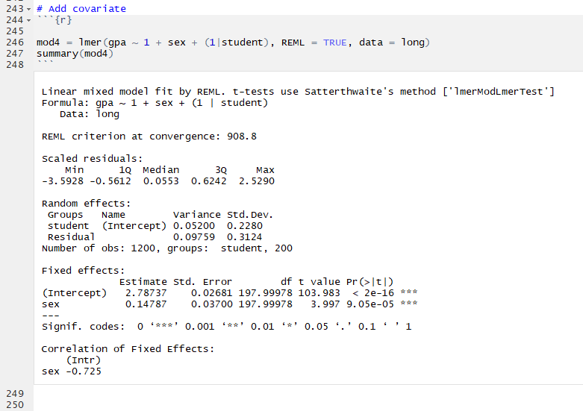

* 1. Interpret the model output.

**Random Intercept: On Average, *male* students mean GPA vary by 0.2280 Standard deviations.**

**Fixed Intercept: The average student GPA for *male* students was 2.787 (The mean of means for males)**

**Fixed slope: Moving from a male to female (sex identity: 0 -> 1) results in an average increase in GPA of 0.148.**

1. Test a linear growth model to determine how GPA changes across the six timepoints and by sex identity

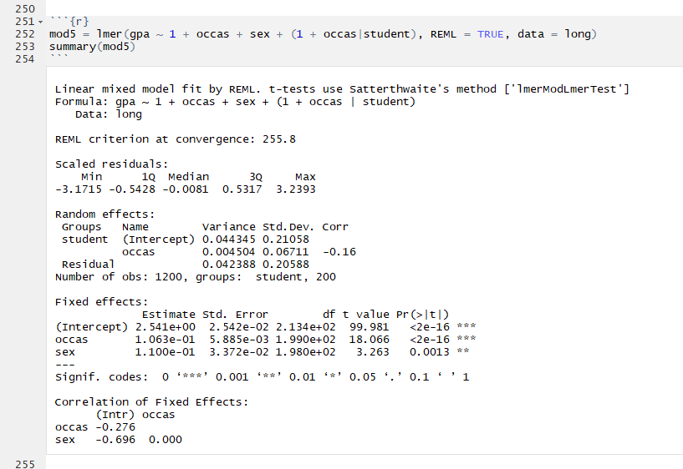

* 1. Interpret the model output and calculate the ICC value. Do results indicate the presence of a linear effect when sex is included as a covariate?

**Random Intercept: For *male* students, starting GPA varied by an average of 0.2106 standard deviations during occasion 0.**

**Random Slope: *Male* students change in GPA across occasion (The slope) varied by an average of 0.0671 standard deviations.**

**Fixed Intercept: On average, *Male* student starting (Occasion zero) GPA was 2.541**

**Fixed Slope (occas): On average, Male Student GPA increased by 0.1063 units across occasion.**

**Fixed slope (sex): Moving from a male to female (sex identity: 0 -> 1) results in an average increase in GPA of 0.1100 at *occasion 0*.**

**YES, these results indicate the presence of a linear effect (fixed slope for occas p <.05).**

**ICC = 0.0045/(0.0045+0.042) ICC = 0.097**

1. Write 3-4 sentences explaining what this series of models suggests about relations between GPA, time, and sex identity among college students.

**This series of models shows that overall, GPA increases over time for most students. This is true for both males and females, but females tend to have an overall slightly greater increase in GPA over time. Despite the difference in trends among males and females, there is still an overall trend when accounting for this fixed effect.**